Documentation of Golang Restful API

In Golang Restful API we have to perform some operations like Create, Update, Read, Delete with the help of http methods like: GET, PUT, POST, DELETE. So, to do this we need to make our own server first.

Here in this I just take an example of Book struct and assign some mock data to Books struct

type Book struct {
ID string `json:"id"`
Isbn string `json:"isbn"`
Title string `json:"title"`
Author *Author `json:"author"`

// Author struct..
}
type Author struct {
Firstname string `json:"firstname"`
Lastname string `json:"lastname"`
}

The above code gives us an idea of Book structure and inside Book there is a pointer to Author struct which contains the firstname and lastname of Author of the Book.
r := mux.NewRouter()

// Mock data
books = append(books, Book{ID: "1", Isbn: "44784", Title: "Book One", Author: &Author{Firstname: "John", Lastname: "Doe"}})
books = append(books, Book{ID: "2", Isbn: "44785", Title: "Book Two", Author: &Author{Firstname: "Steve", Lastname: "Smith"}})
r.HandleFunc("/api/books", getAllBooks).Methods("GET")
r.HandleFunc("/api/books/{id}", getBook).Methods("GET")
r.HandleFunc("/api/books", createBook).Methods("POST")
r.HandleFunc("/api/books/{id}", updateBook).Methods("PUT")
r.HandleFunc("/api/books/{id}", deleteBook).Methods("DELETE")
log.Fatal(http.ListenAndServe(":8087", r))

Now we have to make a router with the help of mux.NewRouter() function and assign some mock data to our Book struct . There are some handler functions which handles the requests and calls an appropriate functions to handle the request or these functions give response to these requests.

Here GET, PUT, POST, DELETE will used for performing read, update, create, delete operaations in postman(used for test an API).

var books []Book

// Get All Books.....
func getAllBooks(w http.ResponseWriter, r *http.Request) {

w.Header().Set("content-Type", "application/json")
json.NewEncoder(w).Encode(books)
}

getAllBooks() function take response(w) and request(r) as an argument of http type. And this function is used to get all the details of all the books. Using GET request in postman, we get all the details of allbooks.

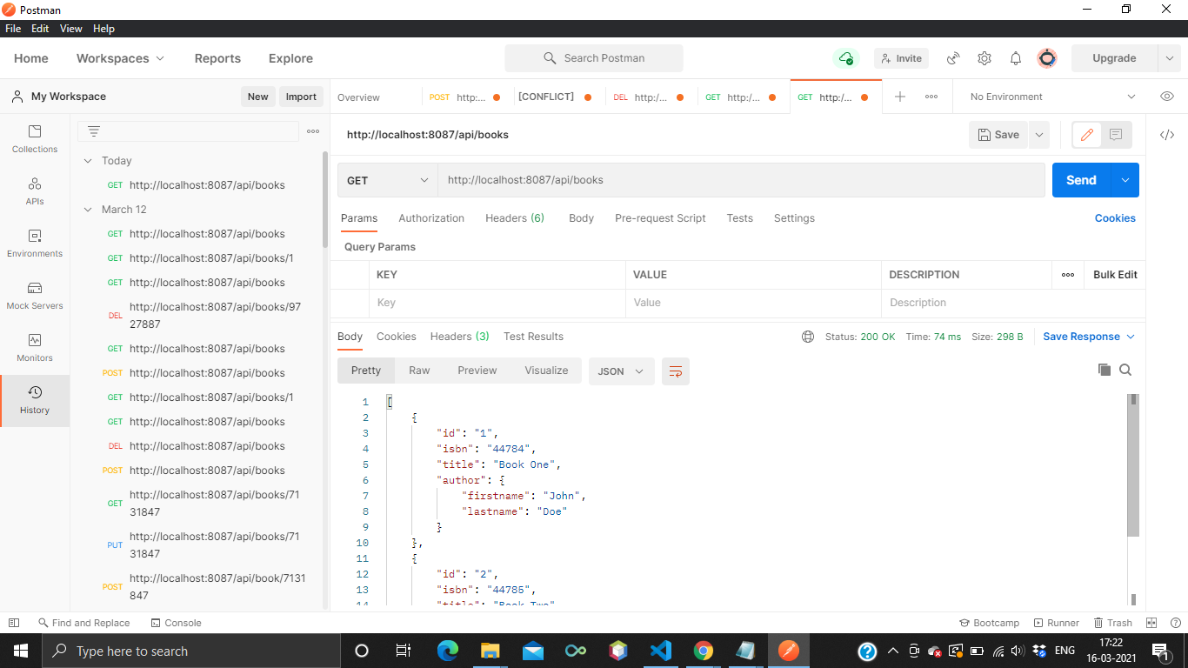

// Get Single Book........
func getBook(w http.ResponseWriter, r *http.Request) {
w.Header().Set("content-Type", "application/json")
params := mux.Vars(r) //Get params

// loop through books and find with id
for _, item := range books {
if item.ID == params["id"] {
json.NewEncoder(w).Encode(item)
return
}
}
json.NewEncoder(w).Encode(&Book{})
}

Similarly, getBook() function takes response(w) and request(r) as an argument of http type. And this function is used to get the details of a single book (if exist) whose id passed as a request. This can be done by using GET request in postman.

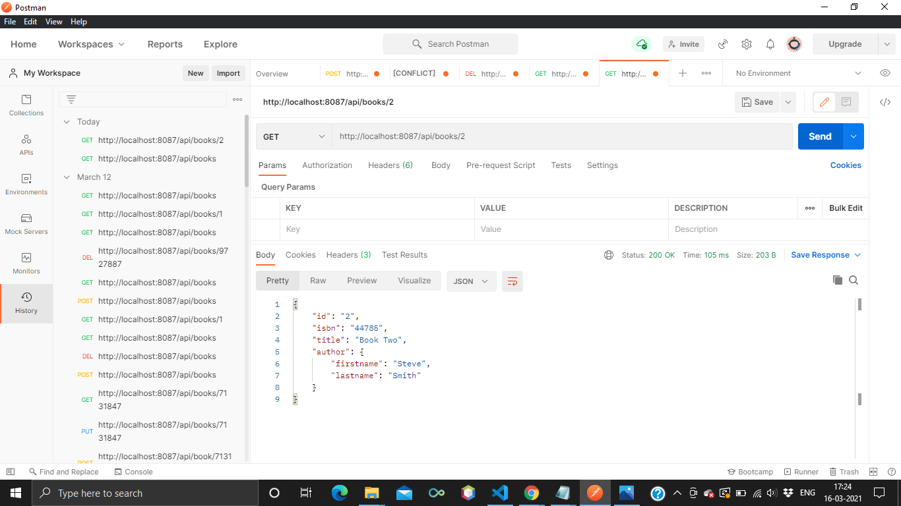

// Update Book....
func updateBook(w http.ResponseWriter, r *http.Request) {

// combination of deleteBooks and createBooks... if we delete an existing item first and after that recreate it on same place with updated values.
// it automatically looks like upadte.

// so first delete pre-existing book....

w.Header().Set("content-Type", "application/json")
params := mux.Vars(r)
for index, item := range books {
if item.ID == params["id"] {
books = append(books[:index], books[index+1:]...)

// and after deleting, create a new book..... Automatically update the Book

var book Book
_ = json.NewDecoder(r.Body).Decode(&book)
book.ID = params["id"]

books = append(books, book)
json.NewEncoder(w).Encode(book)
return

}
}
json.NewEncoder(w).Encode(books)
}

Here updateBook() function take response(w) and request(r) as an argument of http type. And this function is used for basically update the details of an existing book.So approch for update an existing books is first delete the existing book which you want to update and after that recreate a new book on the same place. It automatically looks like an update. So, with the help of PUT request in postman, we update the details.

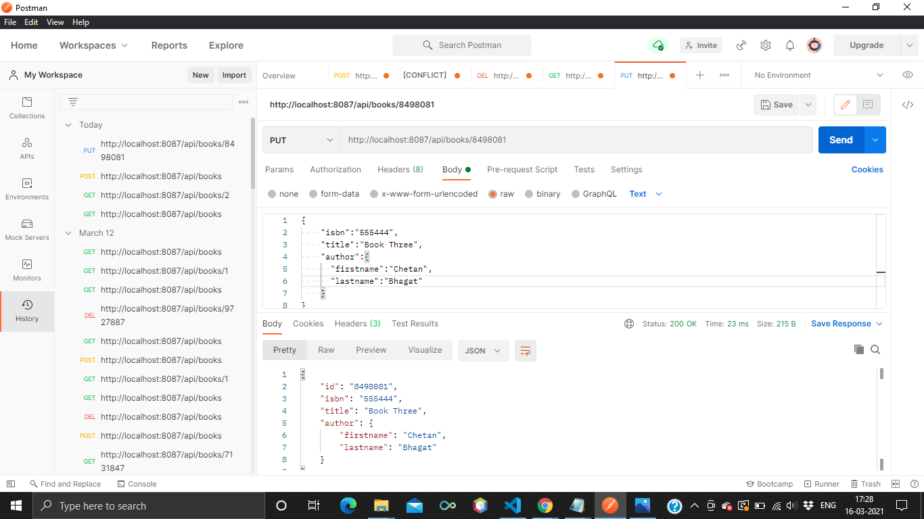

// Create Book.....
func createBook(w http.ResponseWriter, r *http.Request) {
w.Header().Set("content-Type", "application/json")
var book Book
_ = json.NewDecoder(r.Body).Decode(&book)
book.ID = strconv.Itoa(rand.Intn(10000000)) // convert book's id from integer to string
books = append(books, book)

json.NewEncoder(w).Encode(book)
}

Now createBook() function also take response(w) and request(r) as an arguments of http type. And this function is used in creating a new book or add a new book in books slice. And we create a new book by using POST request in postman.

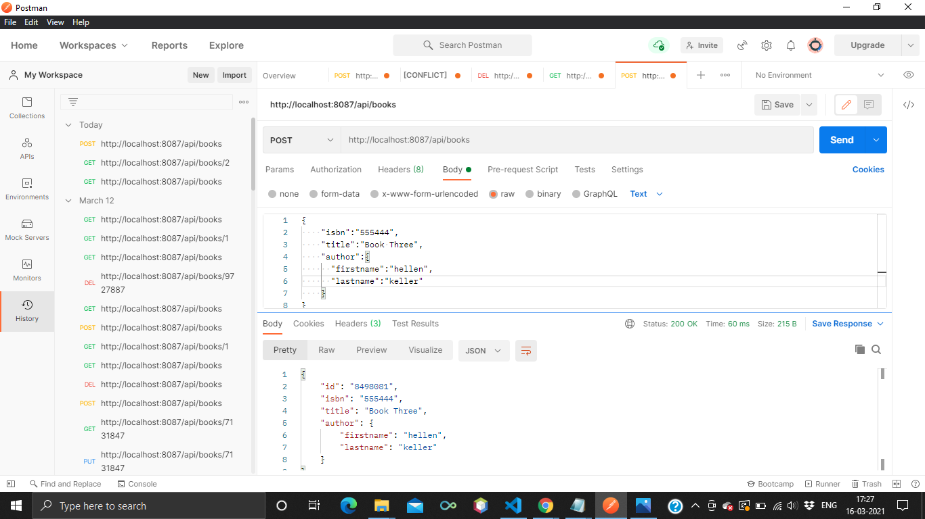

// Delete Book.....

func deleteBook(w http.ResponseWriter, r *http.Request) {
w.Header().Set("content-Type", "application/json")
params := mux.Vars(r)
for index, item := range books {
if item.ID == params["id"] {
books = append(books[:index], books[index+1:]...) // let us suppose i want to delete book whose index is 2
// so it append all the books from index o to 1 and from index 3 to lastindex.
//so automatically 2 indexed will be deleted.

break
}
}

json.NewEncoder(w).Encode(books)
}

At last deleteBook() function also take a response(w) and request(r) as an argument of http type. And this function is used for basically delete the details of a specific book from book slice and after that encode the books slice with the help of json.NewEncoder(w).Encode(books). So, by making DELETE request in postman we can delete book.

